Lab 6 Part 1: Programming

1

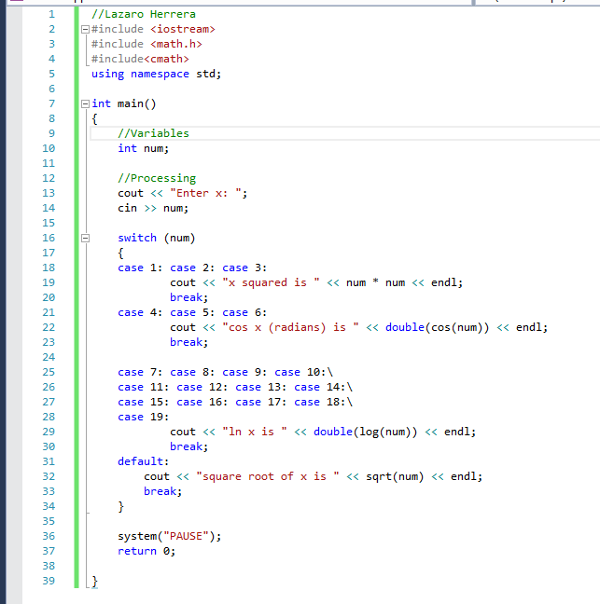

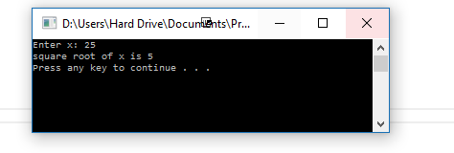

**2**

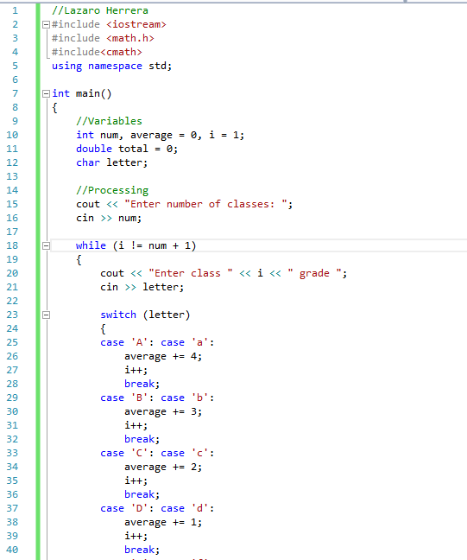

**3**

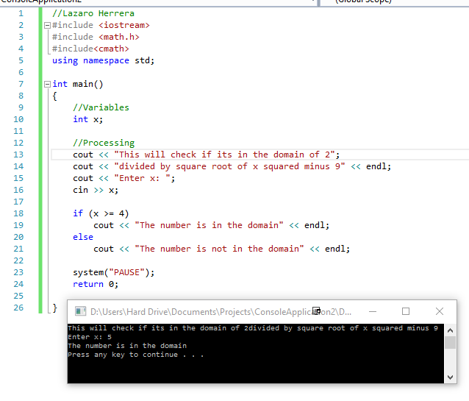

**4**

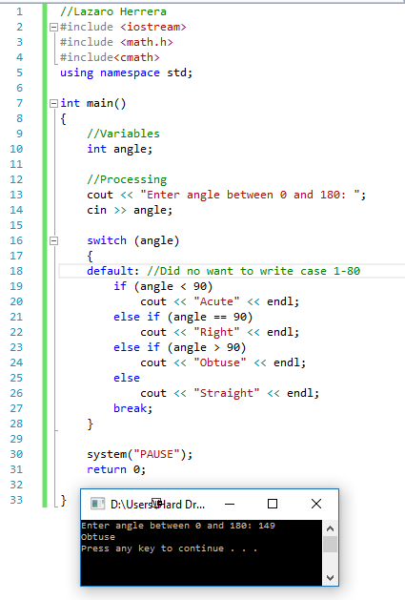

Part 2: Programming output

1. one

2. AC

3. the value of x is 1  
the value of x is neither 1, 4, or 6  
the value of x is neither 1, 4, or 6  
the value of x is 4  
the value of x is neither 1, 4, or 6  
the value of x is 6  
the value of x is neither 1, 4, or 6  
the value of x is neither 1, 4, or 6  
the value of x is neither 1, 4, or 6  
the value of x is neither 1, 4, or 6

Part 3: Correct the error

1. You could initialize a value for i to make it print that case or make it loop to print all cases   
for (int i = 1; i <= 10; i++)

{

switch (i)

{

case 5:

cout << "x is 5\n";

break;

case 10:

cout << "x is 10\n";

break;

default:

cout << "x is neither 5, nor 10\n";

}

2. The incrimination was wrong  
for (int i = 1, j = 2; i <= 10 && j <= 10; i += 2, j += 2)

cout << i << "+" << j << "=" << i + j << endl;

3. Since you want it to stop when either x or y reaches 5 you should use an OR statement as well as a less than or equal to sign  
int x = 1;

for (int y = 2; x <= 5 || y <=5; y++)

{

cout << x*y << endl;

x++;

}